February 2, 2021

**Welcome To CloudFit’s New Command Center**

PICTURE BY OPPORTUNITY LYNCHBURG

“The overwhelming thought in my head is this is the difference between a house and a home. This is our home.” We’re kicking 2021 off with a doozy – the grand opening of our new command center, the official CloudFit Software headquarters building.

This building isn’t just for us, though. It’s for downtown, the people of Lynchburg and surrounding areas, and the growth of our beloved city and region. It’s also a monumental step forward in our business endeavors, giving us the ability to start welcoming more executive leaders to our doorstep.

“I always say that the company is just a piece of paper,” CloudFit Software CTO Carroll Moon says, “but the people are the heart of the company. And for the building, I say that it is brick and mortar (albeit pretty special brick and mortar), but the collaboration that it enables amongst our people is what makes it special.”

Emblazoned with the CloudFit logo, our new home is adjoined to the famous landmark, Monument Terrace, recognized for its cascade of stairs and tribute to veterans. Known as the Carter Glass building, our new hub was constructed in 1931 and dons classic art deco architectural elements. It has “a limestone façade and a rich historical pedigree from its designer to its renowned owners,” says  [Lynchburgva.gov](https://www.lynchburgva.gov/sites/default/files/COLFILES/Financial-Services/Procurement/Stephanie/Carter%20Glass%20RFP%20_%20lr.pdf).

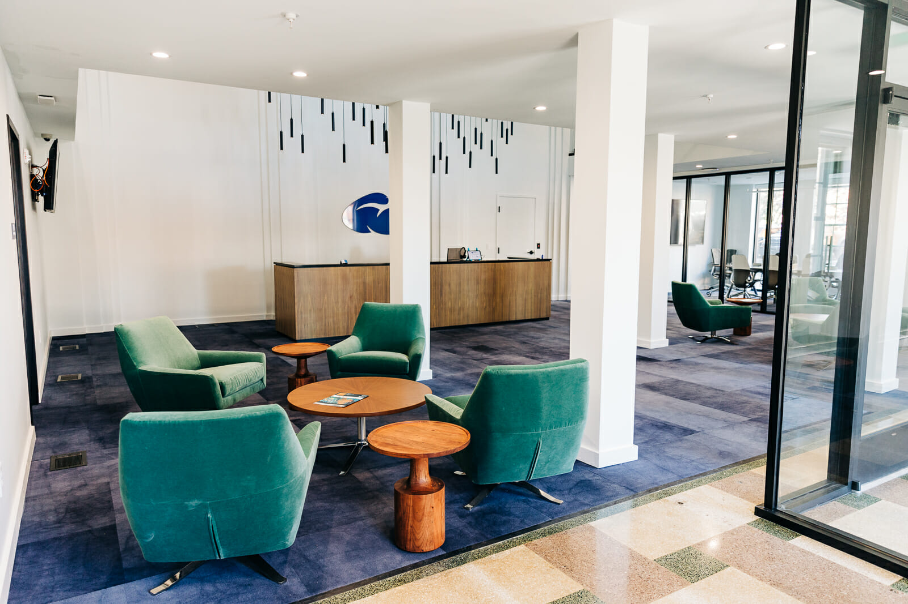

PICTURE BY OPPORTUNITY LYNCHBURG

 The nearly 25,000 square foot, three story edifice was originally created as the local newspaper headquarters, according to [Lynchburgva.gov](https://www.lynchburgva.gov/sites/default/files/COLFILES/Financial-Services/Procurement/Stephanie/Carter%20Glass%20RFP%20_%20lr.pdf). “Sited in the heart of both the Central Business District and Arts & Cultural District, the property is integral to Lynchburg’s civic and cultural core. The Carter Glass building is one of the few structures in the area built in the Art Deco idiom and is a contributing structure to the Downtown-Court House Hill District on the National Register of Historic Places.”

As a company running some of the world’s largest Cloud infrastructures and forging new paths in technology, it only made sense that we occupy a building of such stature and potential. But it’s not only for our sake, but also the well-being of Lynchburg. We are overjoyed to restore a building that sat vacant since 2007 and contribute to bringing life back to downtown.

Local news publications have speculated that our new headquarters will bring 139 more jobs to Lynchburg within the first three years and have a 69-million-dollar economic impact – an incredible accomplishment and a big reason why we laid down roots in Lynchburg in the first place – to help revitalize our region. Central Virginia and Lynchburg are our home and we are honored to play a part in its growth.

While a big step, this is just the *next* step for CloudFit Software, and one that will be memorialized in a building. It’s onward and upward to the next goal!

PICTURE BY OPPORTUNITY LYNCHBURG

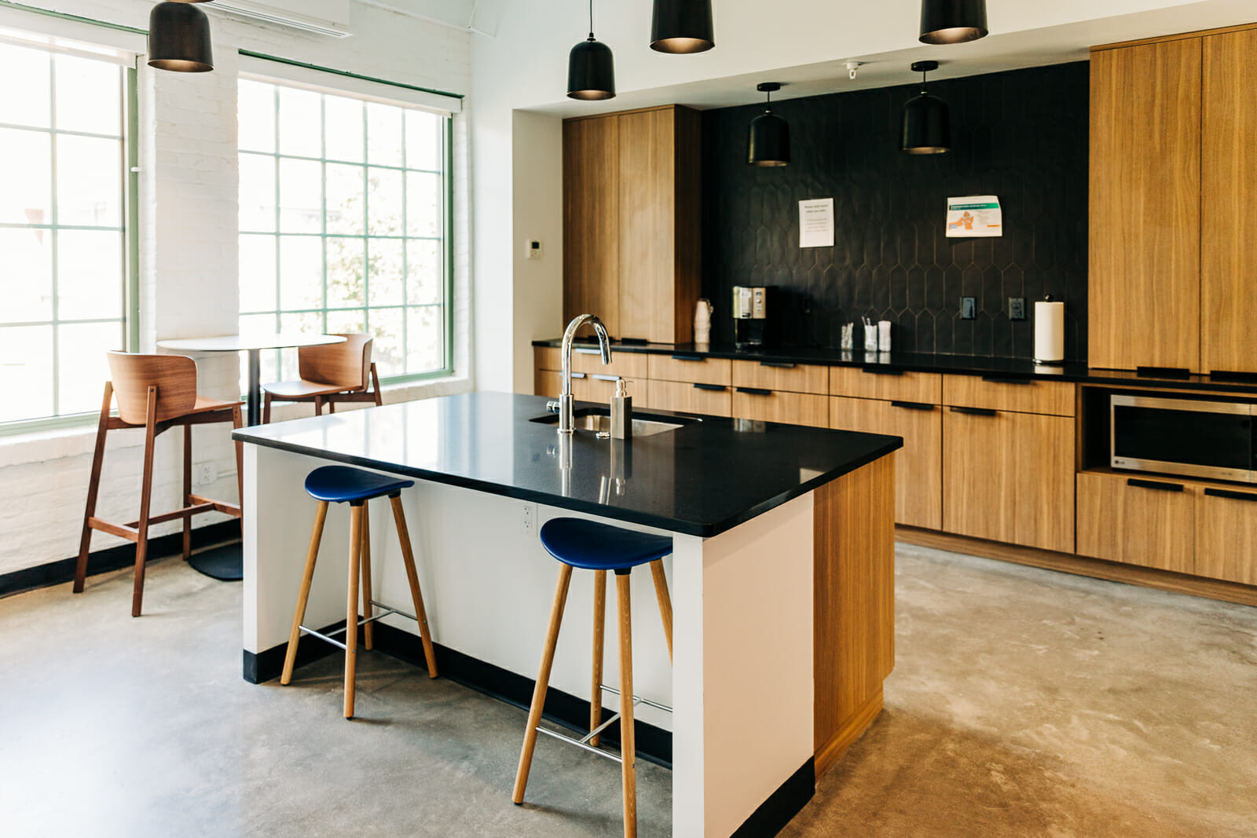

PICTURE BY OPPORTUNITY LYNCHBURG

Filed Under: [Uncategorized](https://www.cloudfitsoftware.com/category/uncategorized/)